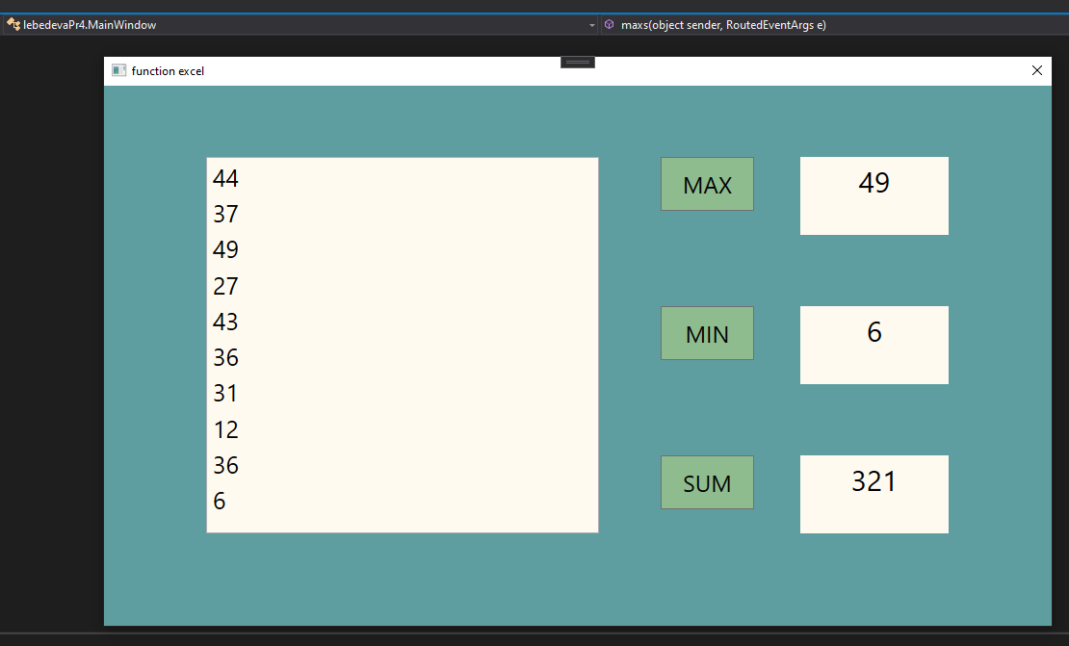

NuGet: 

<Window x:Class="lebedevaPr4.MainWindow"

xmlns="http://schemas.microsoft.com/winfx/2006/xaml/presentation"

xmlns:x="http://schemas.microsoft.com/winfx/2006/xaml"

xmlns:d="http://schemas.microsoft.com/expression/blend/2008"

xmlns:mc="http://schemas.openxmlformats.org/markup-compatibility/2006"

xmlns:local="clr-namespace:lebedevaPr4"

mc:Ignorable="d"

Title="function excel" Height="600" Width="1000" ResizeMode="NoResize" Background="CadetBlue">

<Grid>

<ListBox Name="listbox" Margin="106,74,470,96" Background="FloralWhite" FontSize="25" Foreground="Black">

</ListBox>

<Label Name="max" Content="" Margin="723,74,107,406" FontSize="30" HorizontalContentAlignment="Center" Background="FloralWhite" Foreground="Black">

</Label>

<Label Name="min" Content="" Margin="723,229,107,251" FontSize="30" HorizontalContentAlignment="Center" Background="FloralWhite" Foreground="Black">

</Label>

<Label Name ="sum" Content="" Margin="723,384,107,96" FontSize="30" HorizontalContentAlignment="Center" Background="FloralWhite" Foreground="Black">

</Label>

<Button Click ="sums" Content="SUM" HorizontalAlignment="Left" Height="56" VerticalAlignment="Top" Width="97" Margin="578,384,0,0" FontSize="24" Background="DarkSeaGreen"/>

<Button Click="mins" Content="MIN" HorizontalAlignment="Left" Height="56" VerticalAlignment="Top" Width="97" Margin="578,229,0,0" FontSize="24" Background="DarkSeaGreen"/>

<Button Click="maxs" Content="MAX" HorizontalAlignment="Left" Height="56" VerticalAlignment="Top" Width="97" Margin="578,74,0,0" FontSize="24" Background="DarkSeaGreen"/>

</Grid>

</Window>

using System.Collections.Generic;

using System.Windows;

using Excel = Microsoft.Office.Interop.Excel;

namespace lebedevaPr4

{

public partial class MainWindow : Window

{

public List<int> nums = new List<int>();

public MainWindow()

{

InitializeComponent();

var excel = new Microsoft.Office.Interop.Excel.Application();

for (int i = 0; i < 10; i++)

{

int num = (int)excel.WorksheetFunction.RandBetween(1, 50);

nums.Add(num);

listbox.Items.Add(num);

}

excel.Quit();

}

public void sums(object sender, RoutedEventArgs e)

{

var excel = new Microsoft.Office.Interop.Excel.Application();

sum.Content = excel.WorksheetFunction.Sum(nums.ToArray());

}

public void mins(object sender, RoutedEventArgs e)

{

var excel = new Microsoft.Office.Interop.Excel.Application();

min.Content = excel.WorksheetFunction.Min(nums.ToArray());

}

public void maxs(object sender, RoutedEventArgs e)

{

var excel = new Microsoft.Office.Interop.Excel.Application();

max.Content = excel.WorksheetFunction.Max(nums.ToArray());

}

}

}